File Management In Linux

**Scenario**

You are part of the cybersecurity analyst team. You’ve been tasked with executing basic organizational file system tasks on a Linux system using the terminal (Bash shell).

1. Find and Search Files
2. Create and Remove a Directory
3. Move and Remove a File
4. Create and Edit a File
5. **Find and Search File**
6. **Find file by name**



Search for a file named ***rockyou.txt*** in the ***Desktop* directory.**

1. **Find file by extension**

In this file extension we are finding the file with extension like find the log file using the this command

**find /var/log -name "*.log"**

* Finds all ***.log*** file inside ***/var/log***

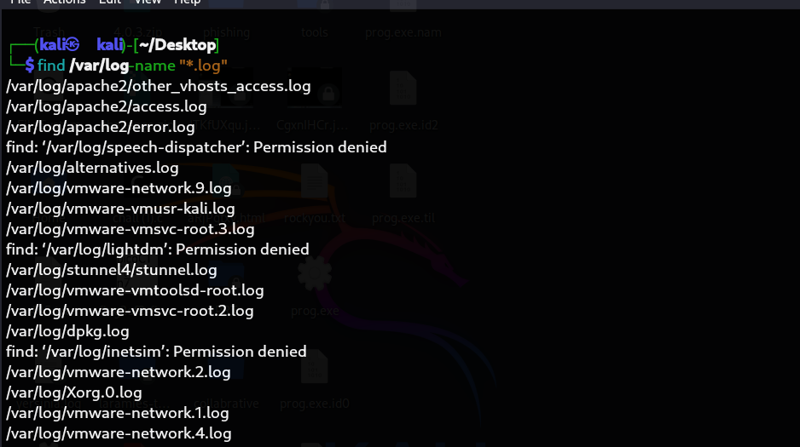

1. **Search inside files for keywords (with grep)**

Now I am go inside the log file and using the some filter command catch the error file and read the error log file. 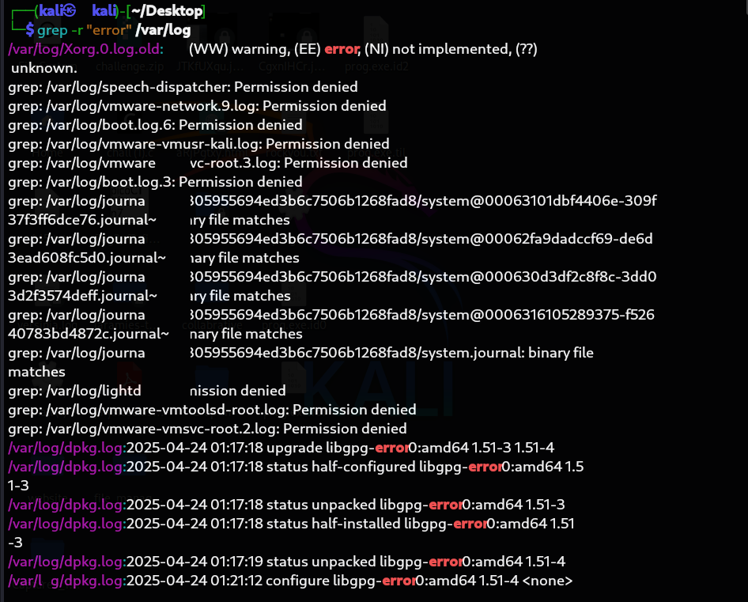

1. **Create and Remove a Directory**

• **Use Case**: Organize reports or logs into folders, clean up unused directories.

Create a Directory:

*mkdir “folder_name”*



Remove the Directory:

***rm -r “directory_name”***



1. **Move and Remove a File**

**Use Case : Move important files to the reports directory and delete temporary files.**

**Command:**

**mv analyst_reports.txt /home/kali/desktop/file_managment/**

**analyst_reports.txt: Is the file want to move into to another file management which is located in the desktop.**



**Then after analysis the file we have to remove that file then I used the rm command for removing the file.**

**Command:**

**rm analyst_reports.txt**



1. **Create and Edit a File**

**Now we are using the command create and edit the file. *Using touch , nano , echo***

**Touch** command use to create a blank file:

**touch final_reports.txt**



**nano** command one of the highly used as editor:

**nano final_reports.txt**



**Echo command used to print something but you and also used for the edit file , create file , add some content in the file.**

**echo “today is $(date)” >> final_reports.txt**

